Name: Brihat Ratna Bajracharya
Roll No.: 19/075
Solution to Exercise 4 (Image Processing and Pattern Recognition)

Thresholding

Question 1. Consider the following 8 by 8 image:
3 148 117 148 145 178 132 174
2 176 174 110 185 155 118 165
0 100 124 113 193 136 146 108
0 155 170 106 158 130 178 170
9 196 138 113 108 127 144 139
6 188 143 183 137 162 105 169
9 122 156 119 188 179 100 151
8 176 137 114 135 123 134 183

Threshold it at
(a) level 100
(b) level 150
What happens to the results of thresholding as the threshold level is increased?

Solution
clearall;

mat_8_8 = [3 148 117 148 145 178 132 174;
2 176 174 110 185 155 118 165;
0 100 124 113 193 136 146 108;
0 155 170 106 158 130 178 170;
9 196 138 113 108 127 144 139;
6 188 143 183 137 162 105 169;
9 122 156 119 188 179 100 151;
8 176 137 114 135 123 134 183;];

figure
subplot(2,2,[1 2]);
imshow(mat2gray(mat_8_8, [min(mat_8_8(:)) max(mat_8_8(:))]),'InitialMagnification','fit');
title('Original 8 * 8 Matrix');

threshold = 100;
new_mat_8_8 = mat_8_8 > threshold;
subplot(2,2,3);
imshow(new_mat_8_8,'InitialMagnification','fit');
title(['(a) Threshold = ' num2str(threshold)]);

threshold = 150;
new_mat_8_8 = mat_8_8 > threshold;
subplot(2,2,4);
imshow(new_mat_8_8,'InitialMagnification','fit');
title(['(b) Threshold = ' num2str(threshold)]);

Output
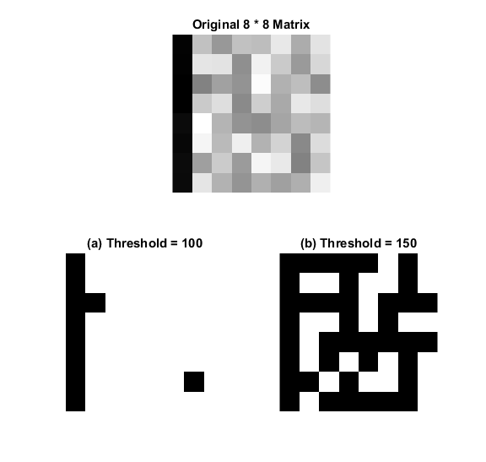Figure 1: Solution to Question 1

Discussion
The more the threshold value is incresed, more finer gray shade is considered as black pixel.

Question 2. Superimpose the image text.tif onto the image cameraman.tif. You can do this with:
>> t = imread('text.tif');
>> c = imread('cameraman.tif');
>> m = uint8(double(c) + 255 * double(t));
Can you threshold this new image m to isolate the text?

Solution
clearall;

t = imread('text.tif');
c = imread('cameraman.tif');

figure
subplot(2,2,1);
imshow(t,'InitialMagnification','fit');
title('(1) text.tif');

subplot(2,2,2);
imshow(c,'InitialMagnification','fit');
title('(2) cameraman.tif');

m = uint8(double(c) + 255 * double(t));
subplot(2,2,3);
imshow(m,'InitialMagnification','fit');
title('(3) Superimposed result');

m_text_isolate = m >= 255;
subplot(2,2,4);
imshow(m_text_isolate,'InitialMagnification','fit');
title('(4) Text isloated from (3)');

Description
Yes, we can isolate the text only from the superimposed images by setting the threshold to 255 (only completely white pixels in superimposed image). The result in shown in Figure 2 (4).

Output

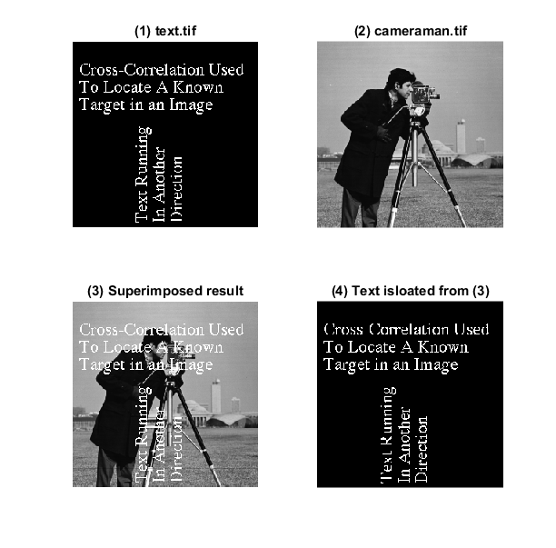Figure 2: Solution to Question 2

Question 3. Create a function that does a contrast stretching transformation for different values of m and E. Apply it to spectrum.tif. Also try a logarithmic transformation.
Hint:
g = c * log(1 + double(f));
g = 1 ./ (1 + (m ./ (double(f) + eps)) .^ E);

Solution
function e4q3
function output = contrast_stretch(f, m, E)
output = 1 ./ (1 + (m ./ (double(f) + eps)) .^ E);
end

function output = log_transform(c, f)
output = c * log(1 + double(f));
end

close all;
f = imread('spectrum.tif');
m = mean2(f);
figure
subplot(3,5,1);
imshow(f);
title('spectrum.tif');

cf = contrast_stretch(f, m, 0.25);
subplot(3,5,2);
imshow(cf);
title('CS (m=2.08, E=0.25)');

cf = contrast_stretch(f, m, 0.5);
subplot(3,5,3);
imshow(cf);
title('CS (m=2.08, E=0.5)');

cf = contrast_stretch(f, m, 1);
subplot(3,5,4);
imshow(cf);
title('CS (m=2.08, E=1)');

cf = contrast_stretch(f, m, 2);
subplot(3,5,5);
imshow(cf);
title('CS (m=2.08, E=2)');

cf = contrast_stretch(f, 16, 0.5);
subplot(3,5,6);
imshow(cf);
title('CS (m=2.08, E=16)');

cf = contrast_stretch(f, 0.5, 0.5);
subplot(3,5,7);
imshow(cf);
title('CS (m=0.5, E=0.5)');

cf = contrast_stretch(f, 1, 0.5);
subplot(3,5,8);
imshow(cf);
title('CS (m=1, E=0.5)');

cf = contrast_stretch(f, 2, 0.5);
subplot(3,5,9);
imshow(cf);
title('CS (m=2, E=0.5)');

cf = contrast_stretch(f, 4, 0.5);
subplot(3,5,10);
imshow(cf);
title('CS (m=4, E=0.5)');

cf = contrast_stretch(f, 8, 0.5);
subplot(3,5,11);
imshow(cf);
title('CS (m=8, E=0.5)');

c = 0.25;
g = im2uint8(mat2gray(log_transform(c, f)));
subplot(3,5,12);
imshow(g);
title(['log transform (c=' num2str(c) ')']);

c = 0.5;
g = im2uint8(mat2gray(log_transform(c, f)));
subplot(3,5,13);
imshow(g);
title(['log transform (c=' num2str(c) ')']);

c = 1;
g = im2uint8(mat2gray(log_transform(c, f)));
subplot(3,5,14);
imshow(g);
title(['log transform (c=' num2str(c) ')']);

c = 2;
g = im2uint8(mat2gray(log_transform(c, f)));
subplot(3,5,15);
imshow(g);
title(['log transform (c=' num2str(c) ')']);
end

Output
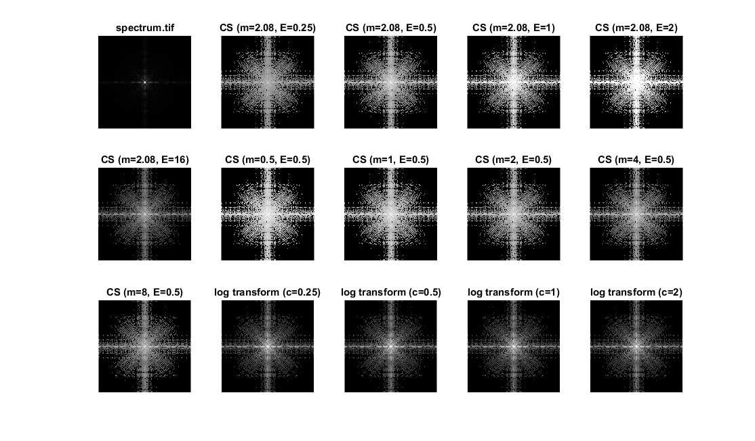Figure 3: Solution to Question 3 (CS= Contrast Stretch),
CS is done for m=0.5, 1, 2, 4, 8 with E=0.5, and E=0.25, 0.5, 1, 2 for m=2.08
and log transform for c=0.25, 0.5, 1, 2

Question 4. Try the following commands (negative image)
>> f = imread('chest-xray.tif');
>> imshow(f)
>> g1 = imadjust(f);
>> imshow(g1)
>> g2 = imadjust(f, [0 1], [1 0]);
>> figure,imshow(g2)
How does changing the value of gamma affect the image?
What types of images are different values of gamma good for?

Solution
clearall;

f = imread('chest-xray.tif');

g1 = imadjust(f);
g2 = imadjust(f, [0 1], [1 0]);
g3 = imadjust(f, [0 1], [1 0], 0.5);
g4 = imadjust(f, [0 1], [1 0], 1);
g5 = imadjust(f, [0 1], [1 0], 2);
g6 = imadjust(f, [0 1], [1 0], 4);
g7 = imadjust(f, [0 1], [1 0], 8);

figure
subplot(3,3,1);
imshow(f);
title('chest-xray.tif');

subplot(3,3,2);
imshow(g1);
title('imadjust result');

subplot(3,3,3);
imshow(g2);
title('imadjust inverted result');

subplot(3,3,4);
imshow(g3);
title('\gamma = 0.5');

subplot(3,3,5);
imshow(g4);
title('\gamma = 1');

subplot(3,3,6);
imshow(g5);
title('\gamma = 2');

subplot(3,3,7);
imshow(g6);
title('\gamma = 4');

subplot(3,3,8);
imshow(g7);
title('\gamma = 8');

Description
Gamma specifies the shape of the curve that maps the intensity values of f to create g. If gamma is less than 1, the mapping is weighted toward higher (brighter) output values. If gamma is greater than 1, the mapping is weighted toward lower (darker) output values. The default value for gamma is 1 (linear mapping). Appropriate gamma values for the images depends upon the type of display it is displayed on.

Output
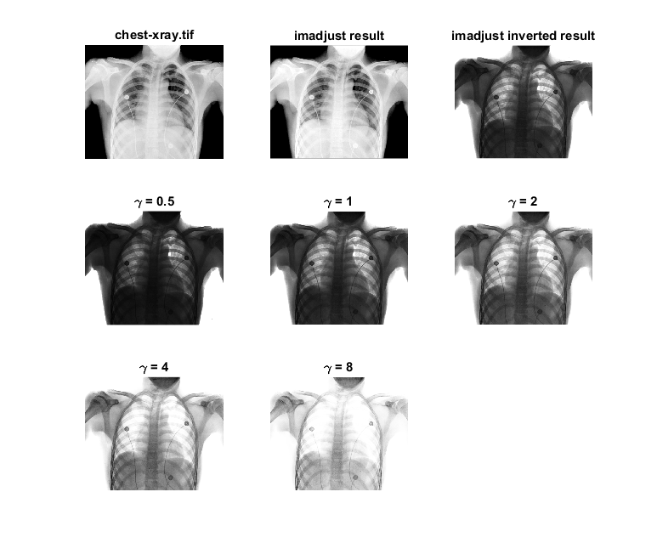Figure 4: Solution to Question 4

Question 5. A large variety of image processing tasks can be accomplished by a technique called spatial filtering. Spatial filtering involves a mask, consists of an array of values (a-i) and has a center (gray). and translated across all possible pixel positions on the image. A new (filtered) image is produced by replacing the intensity value at the center by a linear combination of the intensity values of the center pixel and all neighboring pixels covered by the mask.

1. Try adding different types of noise to ckt-board-orig.tif. Look in the help for the different options in imnoise. Then choose the appropriate filter to remove the noise.
2. Repeat for pollen.tif.
3. Capture your own image and repeat the task as in 1.

Solution
clearall;

% FOR E4Q5 1.
% f = imread('ckt-board-orig.tif');
% FOR E4Q5 2.
% f = imread('pollen.tif');
% FOR E4Q5 3.
f = rgb2gray(imread('brihat.png'));

figure
subplot(2,3,1);
imshow(f)
title('original image');

fn1 = imnoise(f, 'gaussian', 0.5, 0.02);
subplot(2,3,2);
imshow(fn1)
title('gaussian (\mu = 0.5, \sigma^2 = 0.02)');

fn2 = imnoise(f, 'localvar', 0.04 * rand(size(f)));
subplot(2,3,3);
imshow(fn2)
title('localvar');

fn3 = imnoise(f, 'poisson');
subplot(2,3,4);
imshow(fn3)
title('poisson');

fn4 = imnoise(f, 'salt & pepper', 0.2);
subplot(2,3,5);
imshow(fn4)
title('salt & pepper (density = 0.2)');

fn5 = imnoise(f, 'speckle', 0.05);
subplot(2,3,6);
imshow(fn5)
title('speckle (\sigma^2 = 0.05)');

% For E4Q5 1.
noisy_image = fn1;

figure
subplot(3,3,1);
imshow(noisy_image);
title('noisy image');

fil1 = fspecial('average', 6);
fil2 = fspecial('disk', 5);
fil3 = fspecial('gaussian', 15, 2);
fil4 = fspecial('laplacian', 0);
fil5 = fspecial('log', 3, 0.6);
fil6 = fspecial('prewitt');
fil7 = fspecial('sobel');

fil_img1 = imfilter(noisy_image, fil1);
subplot(3,3,2);
imshow(fil_img1);
title('average (size = 6)');

fil_img2 = imfilter(noisy_image, fil2);
subplot(3,3,3);
imshow(fil_img2);
title('disk (radius = 5)');

fil_img3 = imfilter(noisy_image, fil3);
subplot(3,3,4);
imshow(fil_img3);
title('gaussian (size = 15, \sigma = 2)');

fil_img4 = imfilter(noisy_image, fil4, 'circular');
subplot(3,3,5);
imshow(fil_img4);
title('laplacian (\alpha = 0)');

fil_img5 = imfilter(noisy_image, fil5);
subplot(3,3,6);
imshow(fil_img5);
title('log (size = 3, \sigma = 0.6)');

fil_img6 = imfilter(noisy_image, fil6);
subplot(3,3,7);
imshow(fil_img6);
title('prewitt');

fil_img7 = imfilter(noisy_image, fil7);
subplot(3,3,8);
imshow(fil_img7);
title('sobel');

fil_img_sp = medfilt2(noisy_image);
subplot(3,3,9);
imshow(fil_img_sp);
title('median');
% END FOR E4Q5 1.

% FOR E4Q5 2. and 3.
figure
subplot(2,3,1);
imshow(f);
title('original image');

fil3 = fspecial('gaussian', 15, 2);

fil_img_sp = medfilt2(fn1);
subplot(2,3,2);
imshow(fil_img_sp);
title('gaussian - median');

fil_img = imfilter(fn2, fil3);
subplot(2,3,3);
imshow(fil_img);
title('localvar - gaussian');

fil_img_sp = medfilt2(fn3);
subplot(2,3,4);
imshow(fil_img_sp);
title('poisson - median');

fil_img_sp = medfilt2(fn4);
subplot(2,3,5);
imshow(fil_img_sp);
title('salt & pepper - median');

fil_img_sp = medfilt2(fn5);
subplot(2,3,6);
imshow(fil_img_sp);
title('speckle – median');
% END FOR E4Q5 2. and 3.

Outputs
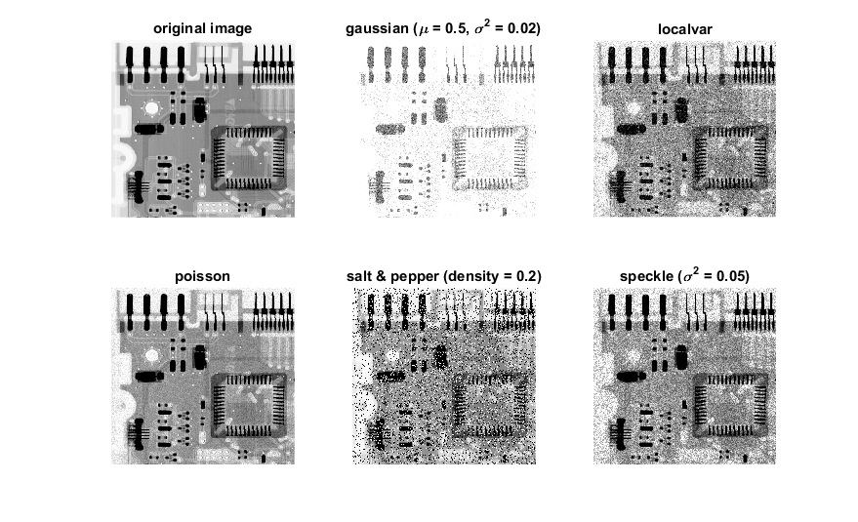Figure 5: Adding noise to ckt-board-orig.tif
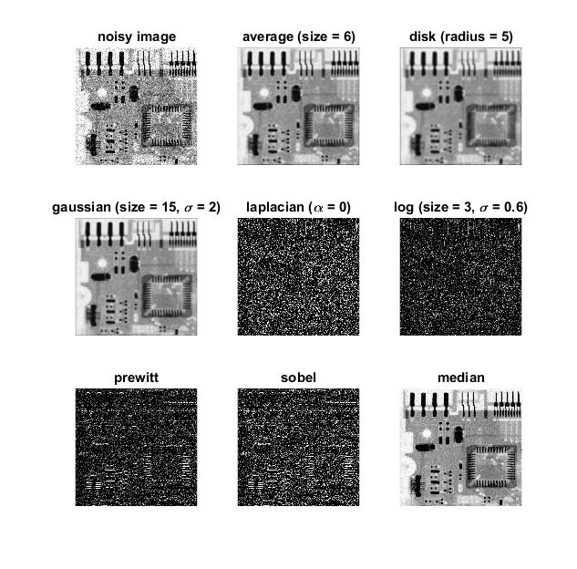Figure 6: Different filters for localvar noise
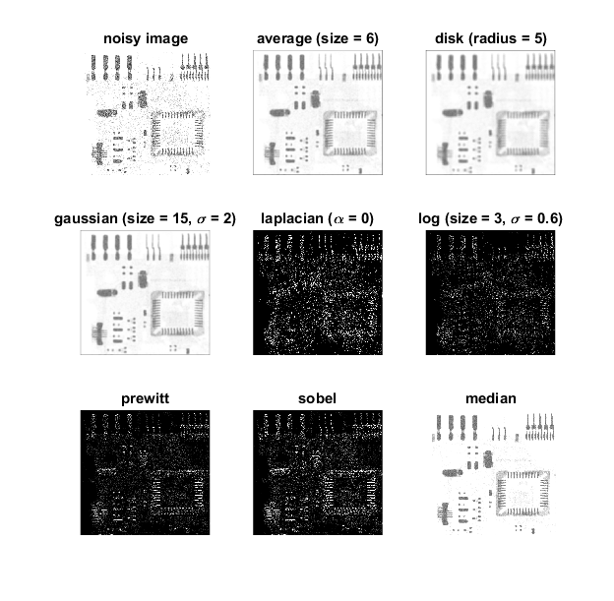Figure 7: Different filters for gaussian noise
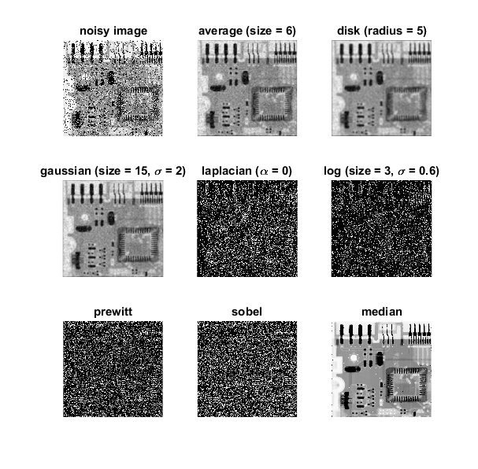Figure 8: Different filters for salt and pepper noise
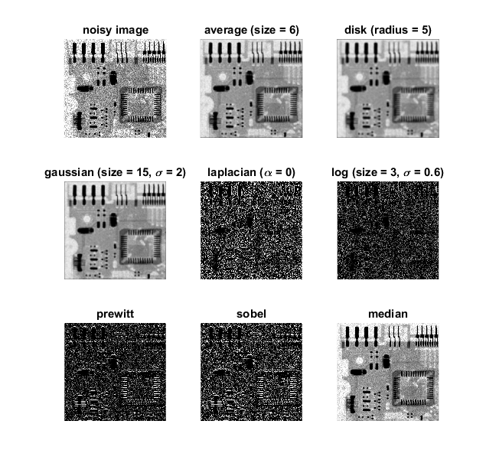Figure 9: Different filters for speckle noise

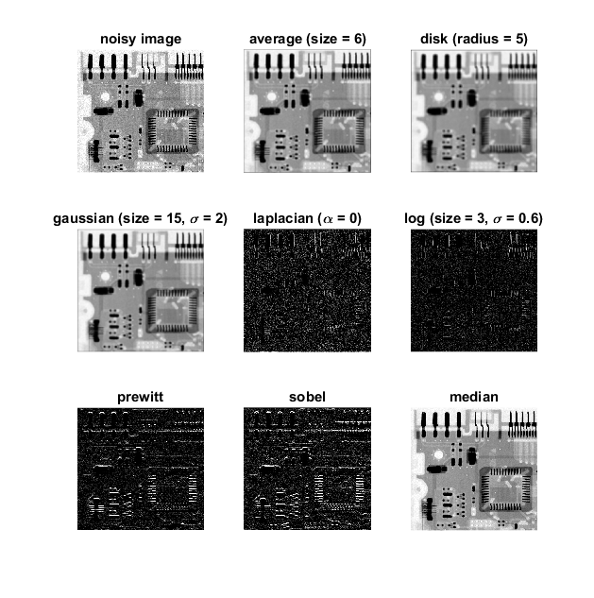Figure 10: Different filters for poisson noise

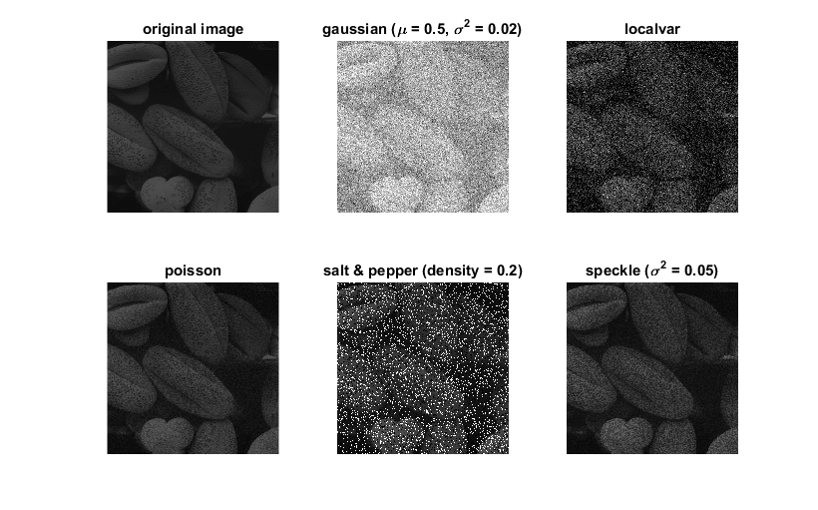Figure 11: Pollen.tif under different noises
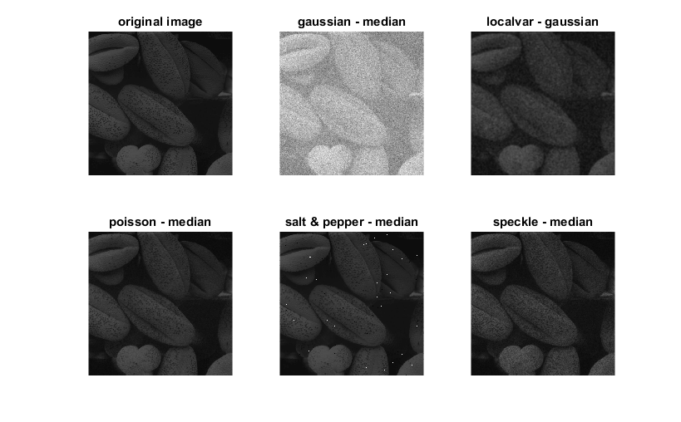Figure 12: Filtered images for different noises (pollen.tif)

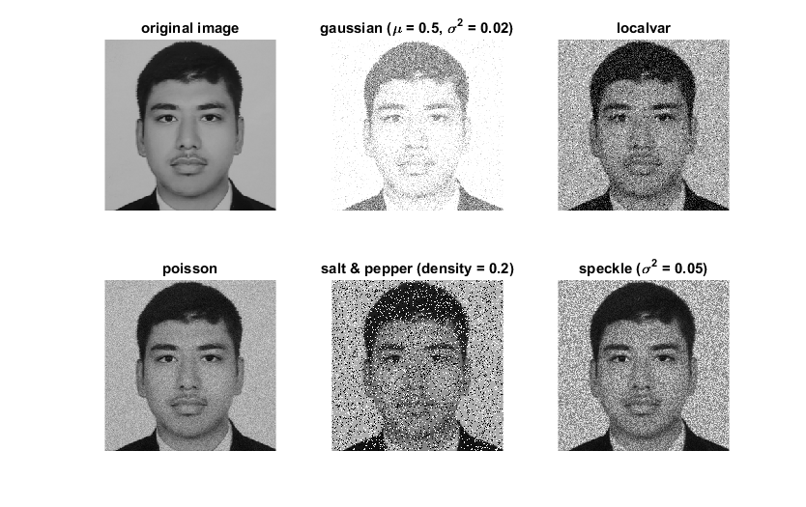Figure 13: My picture under different noises
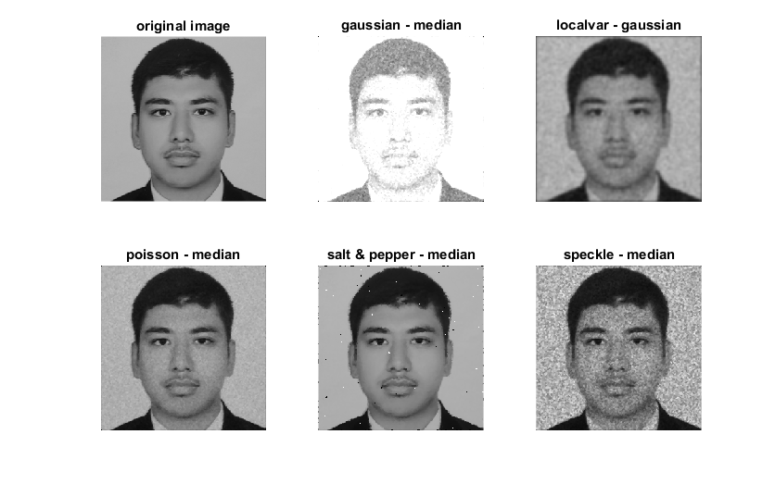Figure 14: My filtered pictures from different noises

